British India 1903 to 1910 Coin Mintage - New Findings
by Haresh Assumal
January 23rd 2015
Last update: Feb 2nd, 2016

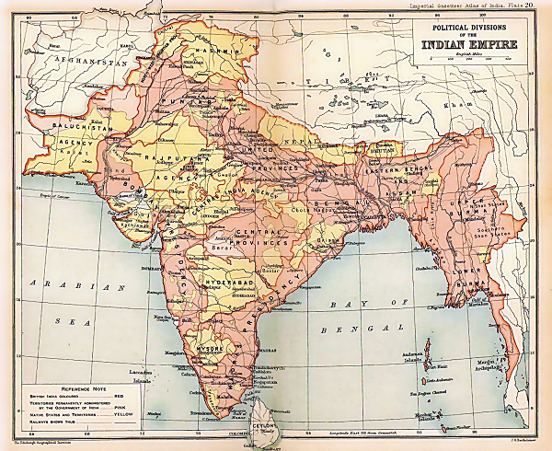
British Indian Empire 1909 Imperial Gazetteer of India by Edinburgh Geographical Institute; J. G. Bartholomew and Sons. - Oxford University Press, 1909. Licensed under Public Domain via Wikimedia Commons

Abstract:
According to Major F. Pridmore’s ground breaking book “The Coins of the British Commonwealth of Nations. Part 4 India. Volume 2, Uniform Coinage”. Edward ¼ Rupee and 2 Anna coins were produced only by the Calcutta mint and none by the Bombay mint. My research shows that the Bombay mint did produce the ¼ Rupee and 2 Anna in 1910.

Researching this further, I find that many of the mintage numbers stated in Pridmore’s book for coins minted between 1903 to 1910 does not match the mint records. Both Krause Mischler and Stevens Weir have repeated these errors since they use Pridmore’s mintage numbers.

Appendix A contains the mintage numbers extracted from the reports.
Appendix B contains snippets of from the Mint Records.

Each year the Bombay and Calcutta mint produced a report, which among other things, stated the number of coins produced. These mintage numbers were for a fiscal year – in other words the mintage numbers are coins produced by the mint from April 1st to March 31st of the next year. The mints however did change the date on the coin after the New Year. For example, a mintage number for 1905 would also include coins dated 1906 i.e. those that were produced from Jan 1st to March 31st of 1906.

Further, the mint reports show large quantities of other coins that were melted to produce new coins, they classified them typically as:

- East India Company coinage
- Rupees
- Other silver coin
- 1911 Rupee

My research shows that there were errors in current publications of the mintage numbers. With this in mind and the fact that the mintage numbers are not for coins dated in a single year and that the mint continued to melt coins to produce new ones, it is very difficult to estimate scarcity of a coin based on the mintage numbers alone.
Two Anna

Mint Records:

Consider this fact, an “Eighth-rupee” in the report is 1/8 of a Rupee which is the 2 Anna coin. Then, take a look at the following statement from the mint records of the Bombay mint for the year 1910-1911.

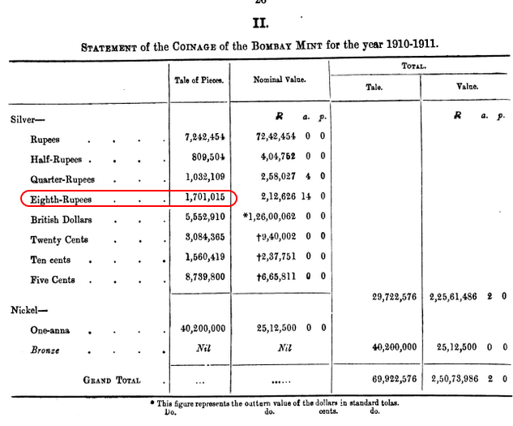

It shows that 1,701,015 2 Annas were indeed produced by the Bombay mint from 1910 to 1911!
Here is the statement from the Calcutta mint for the year 1910-1911

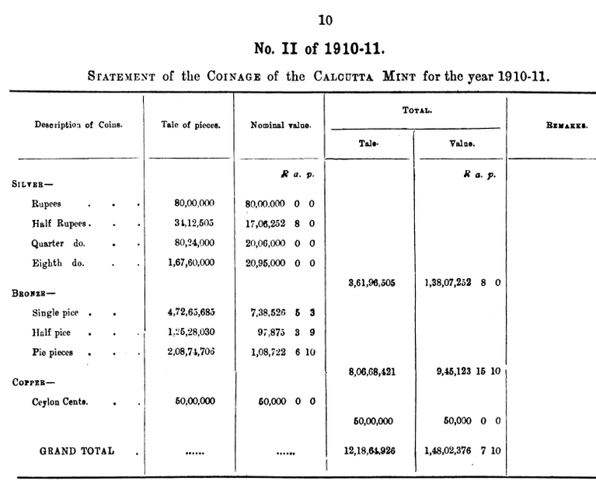

Now one might say that these included 1911 coinage, i.e. that of King George V. However here is a statement in the mint report stating that for this fiscal year 1910-1911 all coins were dated 1910.

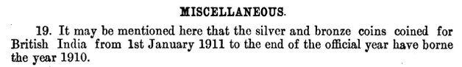

This is because King Edward VII passed away in May 1910 and the mints continued to produce coins with his effigy and using the 1910 date until the new dies of King George V were ready. We know from Pridmore’s book that the new dies only arrived in Calcutta in July 1911 well past the March 31st date of these reports. Which means all the mintages of the above statement are only for 1910 Edward coinage.

In addition, I have found that the numbers that I have extracted from the mint reports differs from Pridmore's mintage for the 2 Anna. Here are the mintage numbers of the 2 Anna that Pridmore / KM/ SW has and ones that I have gathered from the mint reports.

 | India 1903-1910 2 Anna Mintage
My findings from the
Mint Records
Year | Pridmore,  SW, KM: Calcutta Only | Calcutta | Bombay
1903 | 4,434,305 | 14,631,518 | 0
1904 | 14,631,520 | 19,303,364 | 0
1905 | 19,303,364 | 13,030,928 | 0
1906 | 13,030,928 | 22,144,650 | 0
1907 | 22,144,648 | 21,600,000 | 0
1908 | 21,600,000 | 6,768,912 | 0
1909 | 6,768,912 | 1,603,811 | 0
1910 | 1,603,811 | 16,760,000 | 1,701,015

Notice that Pridmore attributes the correct mintage but to the succeeding year, for example the 1903 mintage is incorrectly attributed to 1904.

If you plot the mintage graph using the Pridmore/KM/SW number it looks like:

1903-1910 Mintage Numbers by Pridmore/ SW / KM
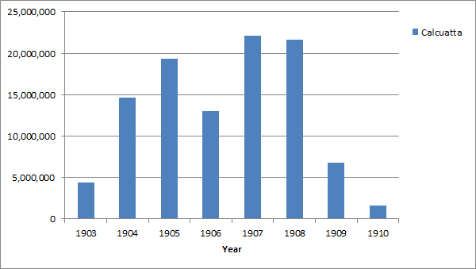

This indicates that the 1910 and 1909 should be scarce, we know that only 1909 is very scarce and 1910 is in fact quite common.

Looking at the mintages that I have extracted from the reports we get the following graph

1903-1910 Mintage Numbers from the mint records
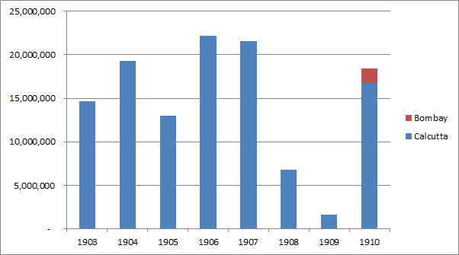

This is more like what we see today - only the 1909 2 Anna is scarce the rest are common, well maybe now the 1910B is a scarce date too.

So how can we identify the 1910 Bombay mint? The Bombay mint placed a dot on the lotus stem. However, these are incorrectly being attributed as coins from the Calcutta mint.

The 1910B 2 Anna:

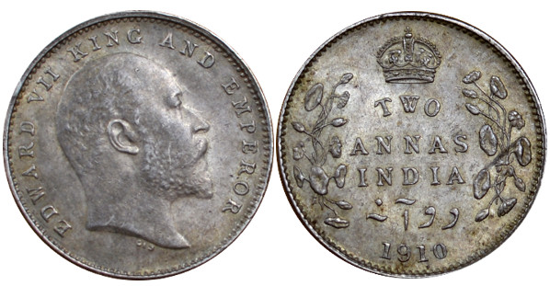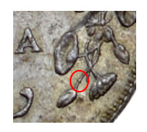
Bombay MM = dot on the stem

Quarter Rupee

I found that the Pridmore mint number match that of the mint records with one very important exception. The Bombay mint produced 1,032,109 ¼ Rupees which is not recorded in Pridmore.

A 1910B ¼ Rupee
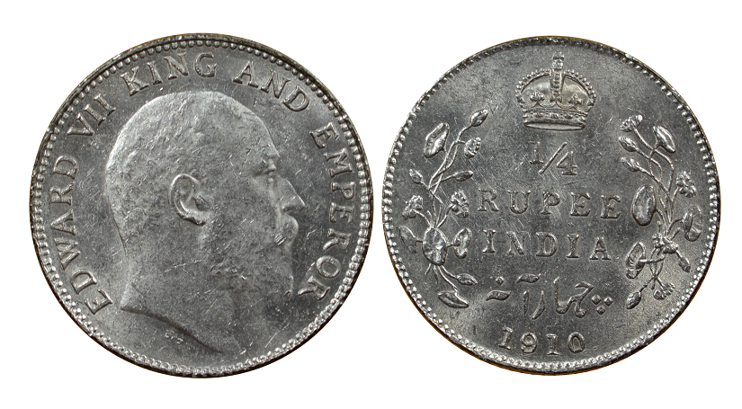
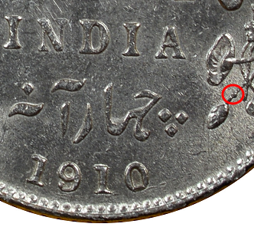

Bombay mint mark on the 1910 ¼ Rupee, dot on the lotus stem on the reverse.

Half Rupee

All the mintage numbers for the ½ Rupee are accurate with one exception, the 1905 Calcutta mint. 1,646,058 coins were minted but Pridmore’s book states it was 823,029. It looks like Pridmore erroneously used the nominal value of Rs 823,029 as the mintage number.

Rupee

There are significant discrepancy with some of the 1 Rupee mintage in Pridmore’s book from 1905 onwards..

Year | Mint | Pridmore Mintage | Mint Records
1903 | Calcutta | 49,403,355 | 65,412,640
1903 | Bombay | 52,969,151 | 96,304,916
1904 | Calcutta | 58,338,617 | 58,338,617
1904 | Bombay | 101,949,291 | 101,949,291
1905 | Calcutta | 51,257,883 | 121,723,238
1905 | Bombay | 76,202,223 | 74,262,383
1906 | Calcutta | 104,797,164 | 93,172,018
1906 | Bombay | 158,953,269 | 160,531,265
1907 | Calcutta | 81,338,000 | 65,342,000
1907 | Bombay | 170,911,816 | 170,927,893
1908 | Calcutta | 20,217,728 | 14,800,000
1908 | Bombay | 10,714,770 | 10,330,598
1909 | Calcutta | 12,758,580 | 11,000,000
1909 | Bombay | 9,538,746 | 9,771,397
1910 | Calcutta | 12,627,013 | 8,000,000
1910 | Bombay | 10,884,946 | 7,242,454

Anna

All the Anna mintage number from 1907 to 1910 match that of the mint records. In 1906 the mint records show that no 1906 nickel anna was issued by the mint for general circulation. Here is an interesting snippet from the 1906-07 mint report reporting on the 1906 coins.

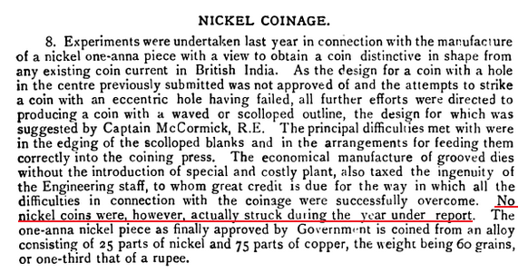
Pridmore, correctly states that the 1906 Anna were “Experimental coinage”..

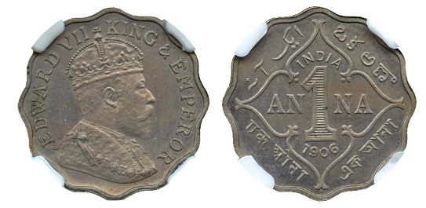
1906 1 Anna (SW 7.140; Pr 925 and 1072)
Copyright © 2013 AH Baldwin & Sons Ltd.

Copper and Bronze Coins 1/12 Anna, ½ Pice and ¼ Anna.

For all the Copper and Bronze coins the Pridmore’s book the mintage numbers match those of the mint records.

There are is an interesting note about the 1907 Calcutta ¼ Anna. The mintage number of the 1907 Calcutta ¼ Anna is stated as 234,681,600 but it Includes 6,400,000 coined for Bikanir State. So the correct number should be 228,281,600.

References:

Thirty Fifth Annual report of The Deputy Masters and Comptroller of the Mint, 1904. London, 1905. page 29.
Administration of the mints of Calcutta and Bombay 1903-04
Administration of the mints of Calcutta and Bombay 1905-06.
Administration of the mints of Calcutta and Bombay 1906-07.
Administration of the mints of Calcutta and Bombay 1907-08.
Administration of the mints of Calcutta and Bombay 1908-09.
Administration of the mints of Calcutta and Bombay 1909-10.
Administration of the mints of Calcutta and Bombay 1910-11, Published in Calcutta 1911.

F. Pridmore, The Coins of the British Commonwealth of Nations, Part 4, vol. 2. Uniform Coinage, East India Company, 1835-58, Imperial Period, 1858-1947

About the Author

Haresh Assumal is a collector of British India, Ceylon, Mauritius, Straits Settlements and East Africa coins and paper money. He can be contacted via email : organgeflagmint[at]gmail[dot]com

Appendix A - Mintages of British India currency coinage from 1903-1910

All mintage numbers are for currency strike only.

Rupee

Year | Mint | Mintage
1903 | Calcutta | 65,412,640
1903 | Bombay | 96,304,916
1904 | Calcutta | 58,338,617
1904 | Bombay | 101,949,291
1905 | Calcutta | 121,723,238
1905 | Bombay | 74,262,383
1906 | Calcutta | 93,172,018
1906 | Bombay | 160,531,265
1907 | Calcutta | 65,342,000
1907 | Bombay | 170,927,893
1908 | Calcutta | 14,800,000
1908 | Bombay | 10,330,598
1909 | Calcutta | 11,000,000
1909 | Bombay | 9,771,397
1910 | Calcutta | 8,000,000
1910 | Bombay | 7,242,454

Half Rupee

Year | Mint | Mintage
1905 | Calcutta | 1,646,058
1905 | Bombay | 0
1906 | Calcutta | 3,036,108
1906 | Bombay | 400,005
1907 | Calcutta | 2,785,607
1907 | Bombay | 1,855,687
1908 | Calcutta | 1,576,498
1908 | Bombay | 0
1909 | Calcutta | 1,586,586
1909 | Bombay | 0
1910 | Calcutta | 3,412,504
1910 | Bombay | 809,504

Quarter Rupee

Year | Mint | Mintage
1903 | Calcutta | 7,060,180
1904 | Calcutta | 10,026,132
1905 | Calcutta | 6,299,742
1906 | Calcutta | 10,671,938
1907 | Calcutta | 11,464,000
1908 | Calcutta | 7,083,812
1909 | Calcutta | Proof only
1910 | Calcutta | 8,024,000
1910 | Bombay | 1,032,109

2 Anna

Year | Mint | Mintage
1903 | Calcutta | 14,631,518
1904 | Calcutta | 19,303,364
1905 | Calcutta | 13,030,928
1906 | Calcutta | 22,144,650
1907 | Calcutta | 21,600,000
1908 | Calcutta | 6,768,912
1909 | Calcutta | 1,603,811
1910 | Calcutta | 16,760,000
1910 | Bombay | 1,701,015

1 Anna

Year | Mint | Mintage
1906 | Bombay | Experimental only, No currency strike
1907 | Bombay | 37,256,000
1908 | Bombay | 22,536,000
1909 | Bombay | 24,800,000
1910 | Bombay | 40,200,000

Quarter Anna

Year | Mint | Type | Mintage
1903 | Calcutta | Copper | 105,974,400
1904 | Calcutta | Copper | 104,594,336
1905 | Calcutta | Copper | 130,058,481
1906 | Calcutta | Copper | 47,228,800
1906 | Calcutta | Bronze | 115,785,600
1907 | Calcutta | Bronze | 228,281,600
1908 | Calcutta | Bronze | 58,066,112
1909 | Calcutta | Bronze | 29,966,071
1910 | Calcutta | Bronze | 47,265,685

Half Pice

Year | Mint | Type | Mintage
1903 | Calcutta | Copper | 5,376,000
1904 | Calcutta | Copper | 8,464,020
1905 | Calcutta | Copper | 8,921,600
1906 | Calcutta | Copper | 6,345,600
1906 | Calcutta | Bronze | 5,859,769
1907 | Calcutta | Bronze | 8,060,231
1908 | Calcutta | Bronze | 10,035,200
1909 | Calcutta | Bronze | 8,492,800
1910 | Calcutta | Bronze | 17,408,000
Twelfth Anna

Year | Mint | Type | Mintage
1903 | Calcutta | Copper | 7,883,044
1904 | Calcutta | Copper | 16,506,127
1905 | Calcutta | Copper | 13,060,449
1906 | Calcutta | Copper | 9,072,000
1906 | Calcutta | Bronze | 2,184,000
1907 | Calcutta | Bronze | 20,985,600
1908 | Calcutta | Bronze | 22,036,800
1909 | Calcutta | Bronze | 12,316,800
1910 | Calcutta | Bronze | 20,871,706

Appendix B - Statements from the Mint records

Bombay Mint 1903-04
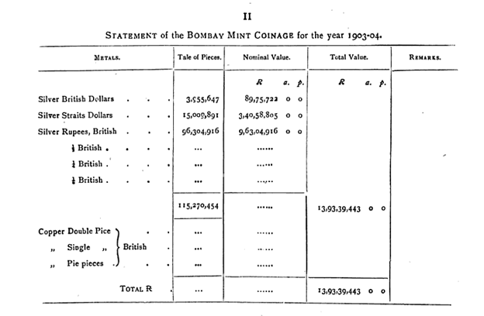
Calcutta Mint 1903-04

